

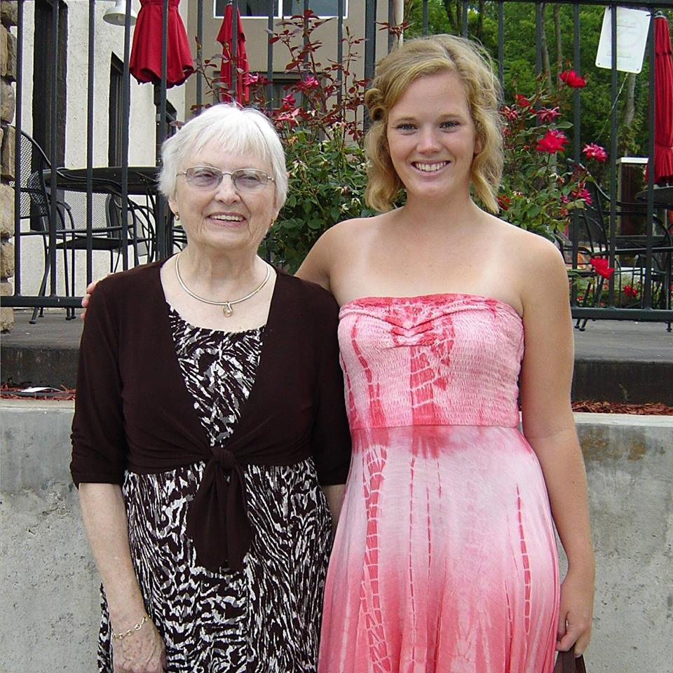

Kaitlyn McManus was accepted into the 4th best occupational therapy school in the nation! Congrats, Kaitlyn!

Kacie Scott (middle) went on a medical mission trip to Costa Rica where she helped serve underprivileged communities by providing medical care.

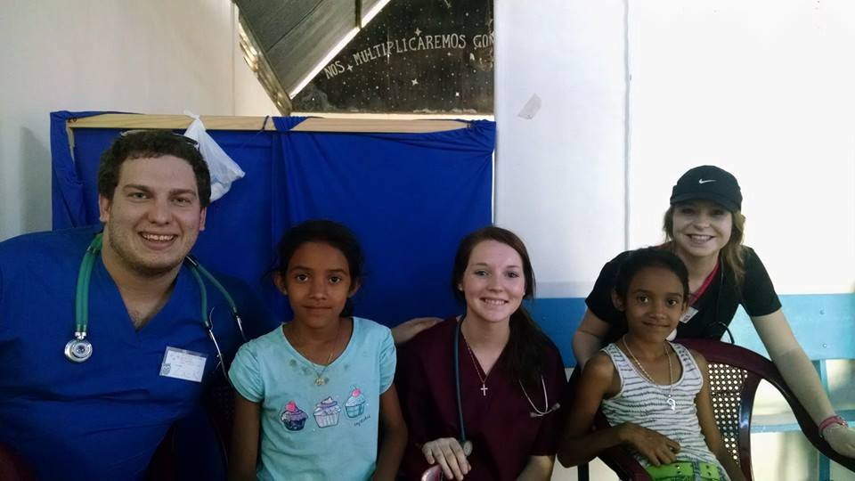

**Charmaine Bunch**

**Spring 2015 Alumni Relations Chair**

[**tlspandas@gmail.com**](mailto:tlspandas@gmail.com)

**(660) 988-7125**

January 21, 2015

**Happy New Year!!**

Hello Ladies! I’d like to start out this first edition newsletter by saying Happy New Year! This edition, I have included some various New Year’s resolutions, news about what the lovely ladies of Tau Lambda Sigma did on their breaks, and a list of all of our new officers! There is also a section with some dates that you might be of interest to you!

Enjoy!

**Welcome Our New Officers!**

The Spring 2015 Officer Board is as follows:

Ava Pacheco – President

Mary Morin – Vice President

Maddy McRaven - Parliamentarian

Ruth Minahan – Secretary

Tiffany Tubbs – Treasurer

Evie Clark – Service

Hannah Stilley – Fundraising

Erin Twenter – Special Events Co-Chair

Susan Camen – Special Events Co-Chair

Abby Tetzlaff – Relay for Life

Charmaine Bunch – Alumni Relations

Meghan Puett – Inter-Organizational

Karlie Bischoff – Historian

Cailin Riley - Public Relations

Callie Warren – Intramurals

Grace Horn – Scholarship

Michaela Idleburg – Risk Management

Alex Carmack – Social

Kelly Mahaffy – Merchandise

Julia Carr – Sunshine

If you would like to contact any of these chairs, please contact me at the address to the right, or contact Ava directly at tlspres@gmail.com.

Vol. 3 Issue 1

Tau Lambda Sigma’s Panda Press

**“Individuals in MIND,**

**sISTERS AT HEART”**

Rachel Foster was admitted to Teach for

America-Kansas City Corps for the next 2 years to teach early childhood education! Congrats, Rachel!

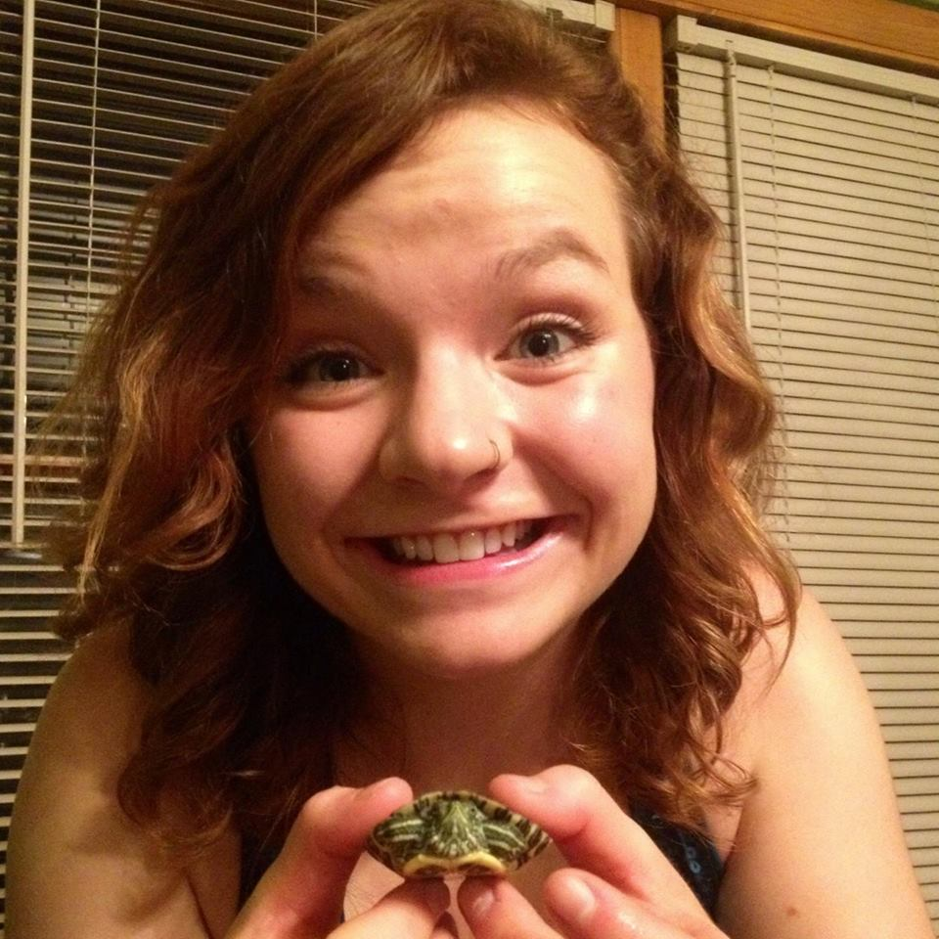

Brandi Clarkson was able to go to the San Diego Zoo and pet her favorite animal, Jake the Sea Lion!

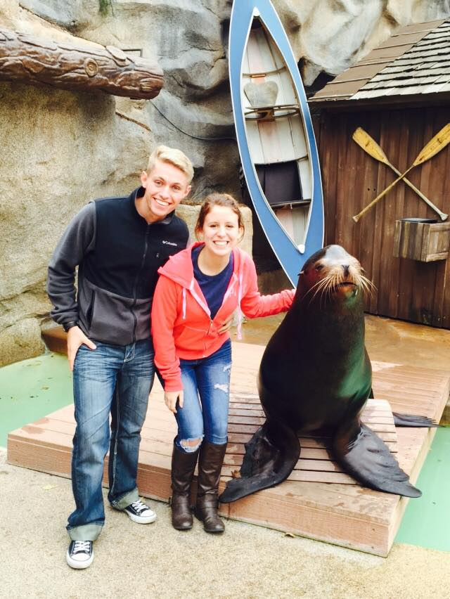

January 21, 2015

Vol. 3 Issue 1

Tau Lambda Sigma’s Panda Press

**New Year’s Resolutions**

Everyone has things that they would like to accomplish in the New Year. Some of us want to eat better, some want to get in shape, while others just want to stop watching so much Netflix. Here are some of the New Year’s Resolutions from our current members!

“To run a half marathon.”

* Rachel Hughes

“To teach myself to play either the guitar or piano (or both!).”

* Mary Kabbaz

“I’m supposed to cut back on hot pockets..or at least be less dependent on them.”

* Erin Twenter

“To get a 4.0 and go on a date.”

* Kelly Morony

“To remember taking time for myself isn’t selfish, and is necessary to function!”

* Alicia Mestre

“To get Victoria’s Secret beach bods and 4.0s!”

* Alex Carmack and Evie Clark

**Upcoming Events**

**Be looking out for information on these events throughout the semester!**

**February 2-5th: Spring Recruitment**

**February 6th: Pinning Ceremony/Bid Night**

**February 7th: Service Day**

**February 14th: Polar Plunge**

**February 20-22nd: Special Women’s Weekend**

**February 28th: Date Party**

**Later in the semester…**

**March 20th: Initiation**

**April 11th: Relay for Life**

**April 17-19th: Alumni Weekend**

**April 18th: Bar Crawl**

**April 25th: Special Olympics**

**May 2nd: Sigma Ceremony**

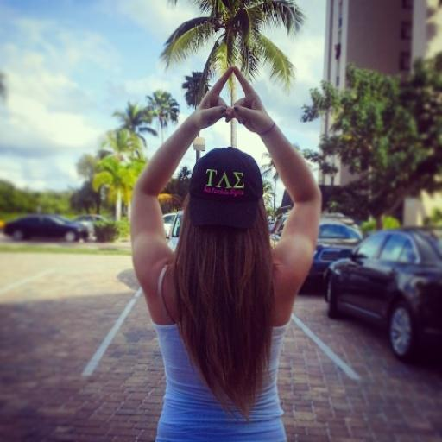

Bailey Leftwich went on family vacation (and represented TLS the entire way!)

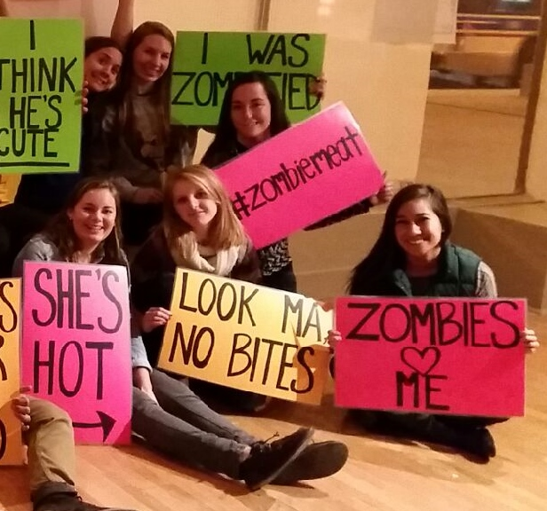

“So for NYE, my best friends from high school and I went to Chicago. We found this thing called Trapped In A Room With A Zombie. Basically, there's a room in the Chicago Fine Arts building that they load with clues and the purpose is to figure out all the clues to escape within an hour. But there's a catch - there is a zombie attached to a chain in the corner of the room! Every 5 minutes, her chain got longer an if she touched you, you were out! My friends and I unfortunately did not escape in time and were eaten, but I definitely recommend it to any alum who live/visit Chicago. It was so much fun!”

* Shari Fieser

**“iNDIVIDUALS IN MIND,**

**SISTERS AT HEART”**

Tau Lambda Sigma’s Panda Press

January 21, 2015

Vol. 3 Issue 1